Integration Testing Plan
 |  |  | Observed Behavior *
# | Data Input | Expected Behavior | Run 1 |  | Run 2 |  | Run 3
 |  |  | (P/F) | H/M/L | (P/F) | H/M/L | (P/F) | H/M/L
 | Login as basic user with by entering username and password | The user is navigated to the respective home page if the login details are correct. | P |  | P |  | P
 | Click on create account button to sign up. Fill all the mandatory details and click on submit button for a new guest user account. | It should navigate to basic user home page which shows how to use the app. | F | L | P |  | P
 | Login to the app, Perform user related activities, Click on logout button | Should be able to Sign out from the app after performing user related activities | P |  | P |  | P
4. | Login to the app by entering registered email id and password, Select the registered fraternity from the list of fraternities | Should be able to selects the registered fraternity to launch the request | P |  | P |  | P
5. | Login to the app by entering registered email id and password,  Select the registered fraternity from the list of fraternities, Select incident type | Should be able to selects the anticipating incident type in the fraternity to launch the request. | P |  | P |  | P
6. | Login to the app by entering registered email id and password, Select the registered fraternity from the list of fraternities, Select incident type, Select the user location | Should be able to launch the request for the assistance | P |  | P |  | P
7. | Login to the app by entering registered email id and password, Select the registered fraternity from the list of fraternities, Select incident type, Select location, Click on launch request button to submit, Click on submitting icon to access the request | Should be able to track the submitted request | P |  | P |  | P
8. | Login to the app by entering registered email id and password, Select the registered fraternity from the list of fraternities, Select incident type, Select location, Click on launch request button to submit, Click on submitting icon to access the request, Enter the text in the comment box in the request dialog box and submit | After submitting the request, the user has to provide the situation details. | P |  | P |  | P
9. | Login to the app by entering registered email id and password, Click on the Emergency launch request button to submit | Should be able to launch emergency request in case of immediate help | P |  | P |  | P
10. | Login as Host to the app by entering registered email id and password, Select incident or request, Click on generate report | Should be able to generate the report on incident statistics and request statistics | P |  | P |  | P
11. | Click on forgot password button, Enter email id, Click on submit button | Should be able to regenerate or reset your password in case the user forgets password. | P |  | P |  | P
12. | Login as Guard to the app, Click on active requests button | Should be able to view the list of active requests to claim the requests | P |  | P |  | P
13. | Login as Guard to the app, Click on active requests button, Select the request, Click on claim button | Should be able to claims the request | P |  | P |  | P
14. | Login as Guard to the app, Click on history button | Should be able to view the list of resolved requests | P |  | P |  | P

F - Expected and observed behavior is different. This is classified as a defect.
H - High severity defect (System crash / incorrect data which impacts other regions / etc.)
M - Medium severity defect (Execution can continue / Incorrect data which does not impact other regions / etc.)
L - Low severity defect (Aesthetics / Message wording / Menu options / Wrong alarms / Help problems / etc.)

Integration testing with screenshots

User Login

Purpose | The purpose of this test is to ensure that the user provided valid login details
Test Description | 1) Enter the login credentials  2) Send the login details to the web service.  3) Validate user results at the service end.
Expected Results | The user is navigated to the respective home page if the login details are correct.

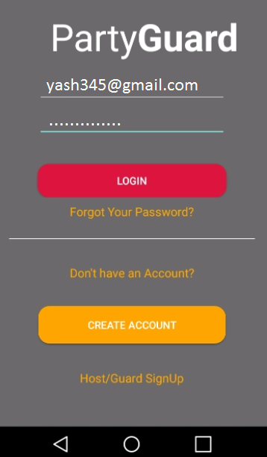

Login button is unable to function on the first click, so this is a failure.

User Sign Up
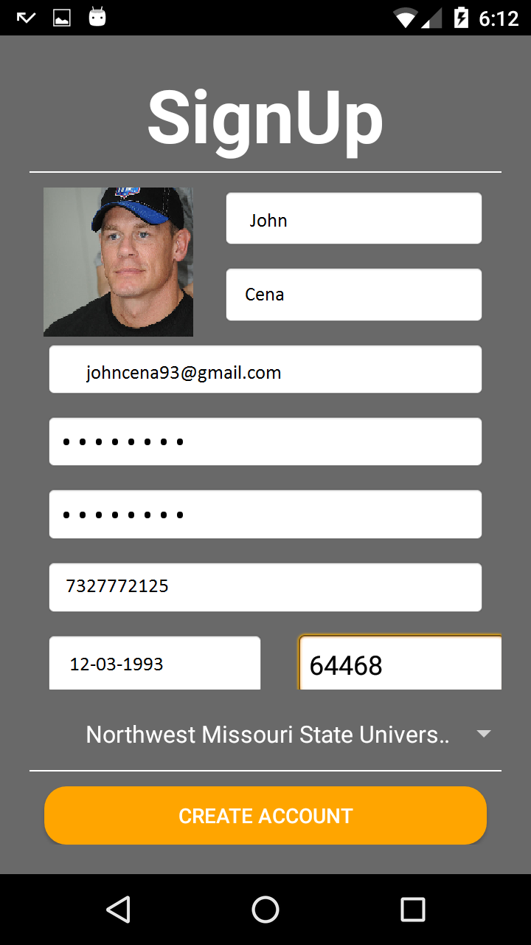

Purpose | Validate sign up details.
Test Description | 1) Enter all the required fields  2) Validate the details and post to the service.
Expected Results | If the sign up is successful, user is navigated back to the login page.

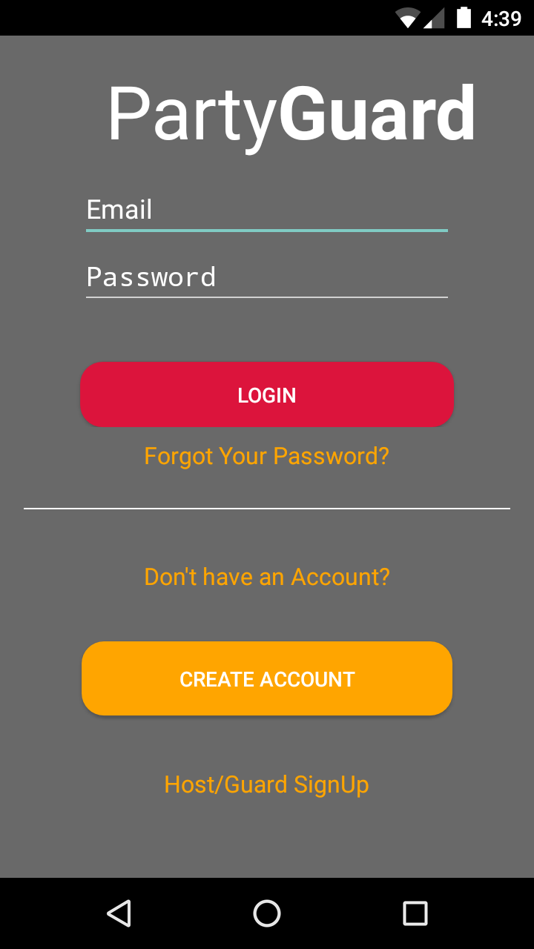

Forgot Password

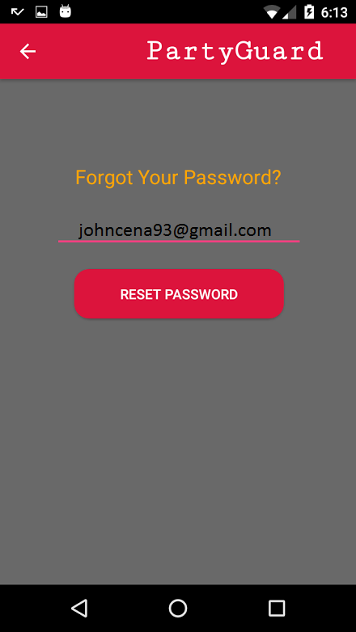

Purpose | Validate that user provided correct email
Test Description | 1) Provide the email provided during registration  2) Post the email to the service and validate the email.  3) Send a link to email to reset password.
Expected Results | The user is navigated back to the login page.

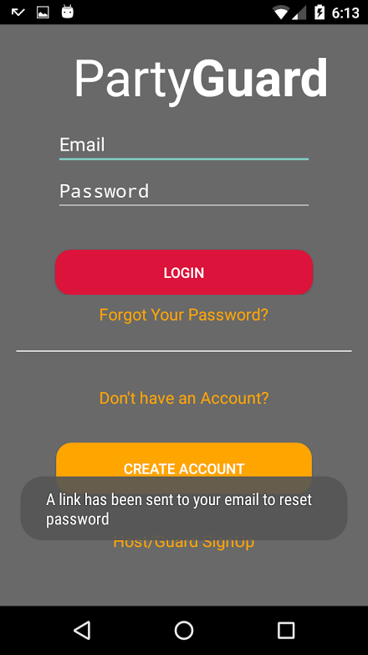

Choose University

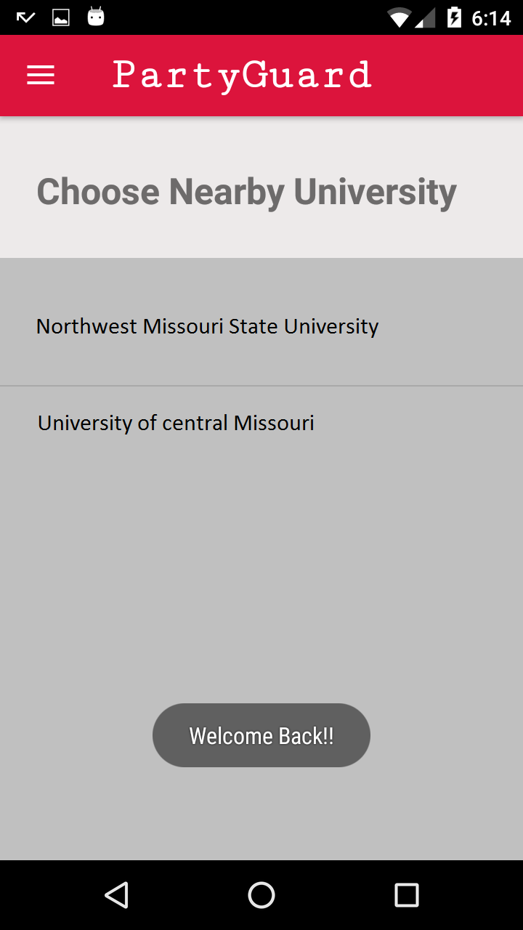

Purpose | Select a university from the list of universities provided.
Test Description | 1) All the universities provided in the service list are being displayed in the screen.
Expected Results | After selecting university screen, user is navigated to fraternity screen.

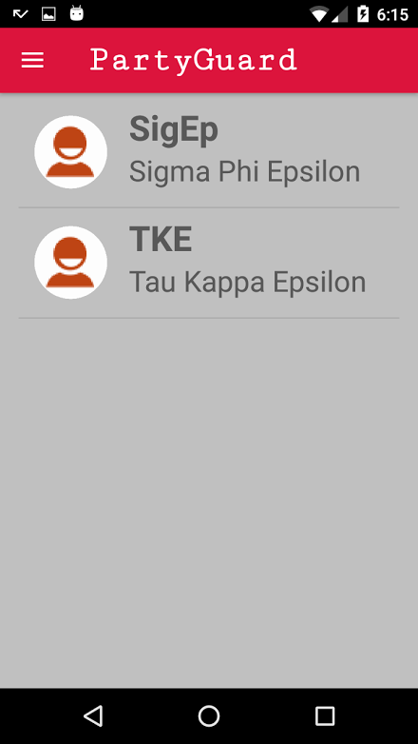

Profile Screen
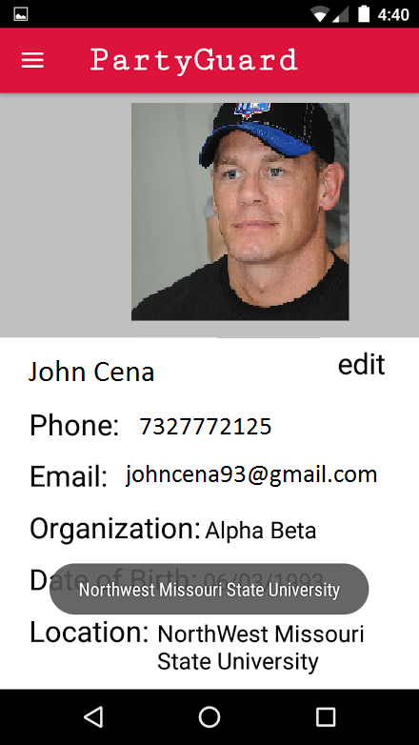

Purpose | User can view his profile and also edit the profile.
Test Description | 1) User can select any of the tab in the screen.  2) The data is fetched from the service and displayed in the screen.
Expected Results | All the edited details are posted to the service successfully.

PG Team
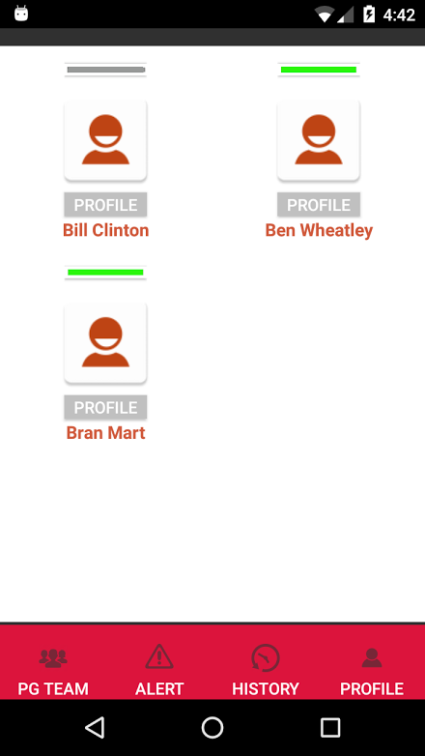

Purpose | All the guards in the fraternity are displayed in the screen.
Test Description | 1) Available guards are displayed with help of toggle bar.
Expected Results | By clicking on particular grid cell, guard profile can be viewed.

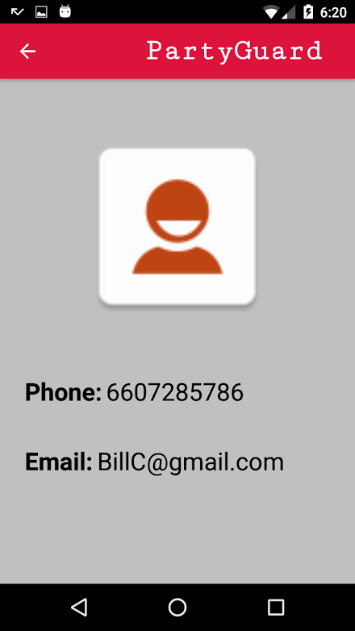

Alert Screen

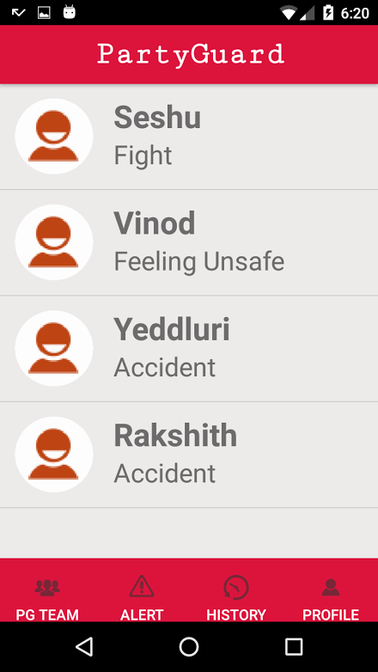

Purpose | All the alerts are displayed in this screen.
Test Description | 1) The alerts posted by basic user are added to this screen.
Expected Results | By clicking on a particular alert, alert details can be viewed. Host user can allot the guard in this screen.

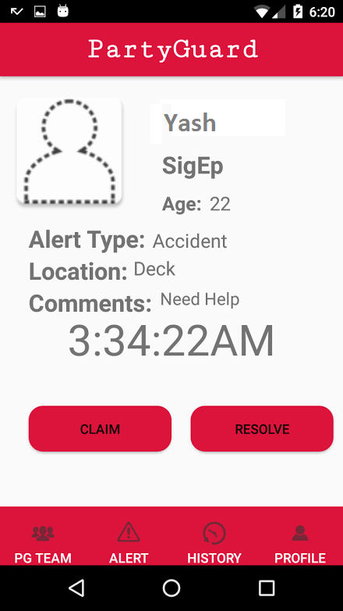

Profile Screen
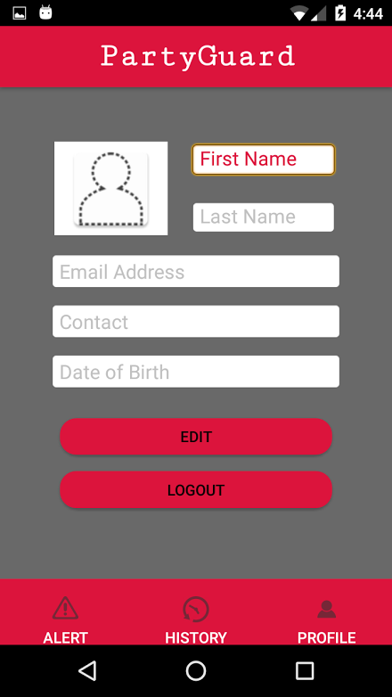

Purpose | User can view his profile and also edit the profile.
Test Description | 1) The data is fetched from the service and displayed in the screen.
Expected Results | All the edited details are posted to the service successfully and user can logout of the screen here.

